## Practical 8: JavaScript(IV)

1. Write a web page which
   1. Use input box to get 2 numbers from users
   2. When the “Add” button is clicked, calculate and display result

## Sample:

## 

<html>

<head>

<title>JavaScript - using function</title>

<script>

function add(){

*// get the value of element with id n1*

*// get the value of element with id n2*

*// calculate result*

*// display the result at the <span> of id result*

}

</script>

</head>

<body>

<label>First Number:<input type="number" id="n1"/></label>

<label>Second Number:<input type="number" id="n2"/></label>

<input type="button" value="Add" />

<p>

Result = <span id="result"></span>

</p>

</body>

</html>

## Let’s make a simple photo Gallery as below:

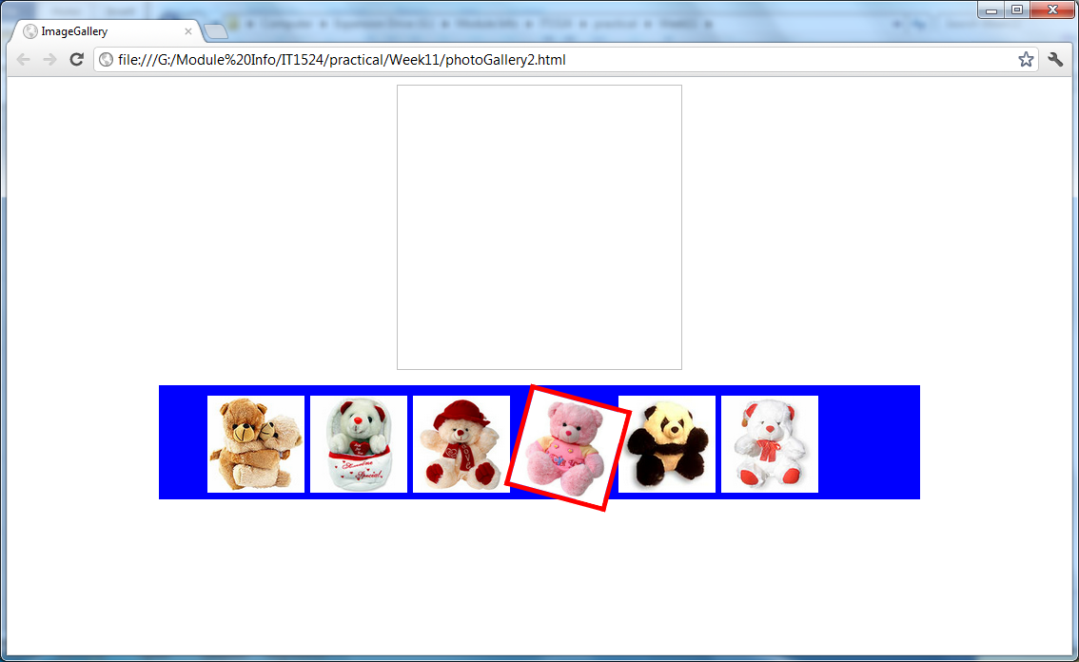

When you hover any of the small pictures, it will be twitted by 45% (done for you using CSS).

When the picture is clicked, you should see a larger version of picture displayed on top:

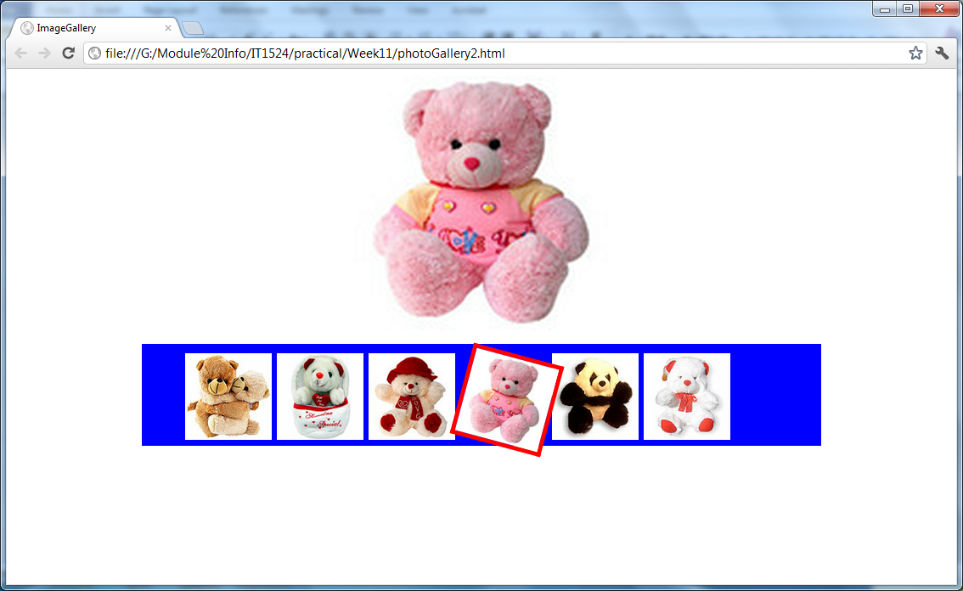

**Steps:**

1. Copy the **photoGallery(Incomplete).html** to your working folder.
2. Make sure that all necessary images are stored in the **images** folder under the same working folder
3. Complete the function ***showPicture(theImg)*** and save it as **photoGallery.html**.

## Write a super simple editor for web page.

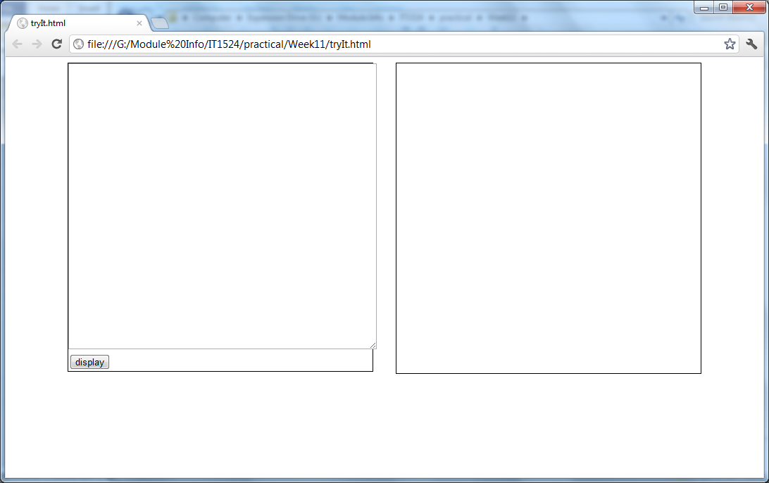

After you enter the html/CSS content to the division on the right, click the display button, result will be shown on the right.

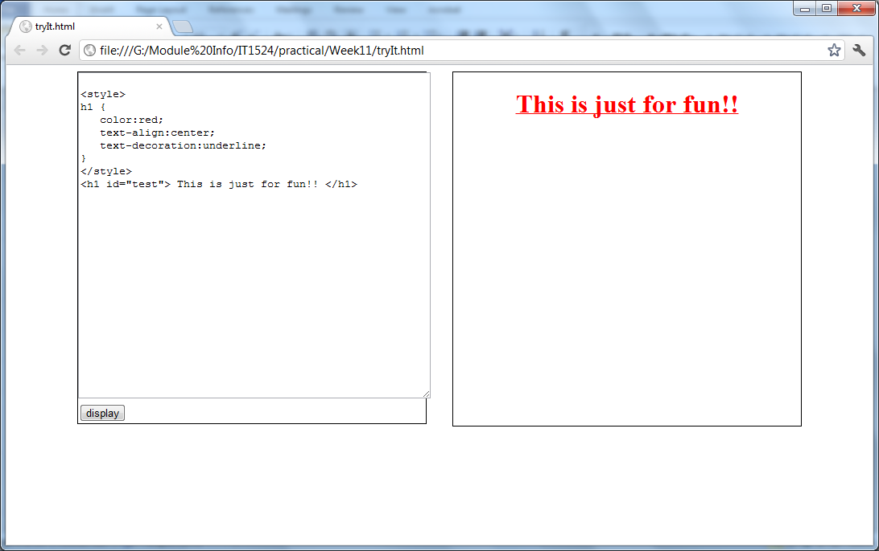

**Steps:**

1. Copy the **tryIt(Incomplete).html** to your working folder.
2. Complete the function ***toDisplay()***  and save it as **tryIt.html**.

## Adding new list item dynamically. When user clicks at to add item, user will be prompted for new item. Enter the new item and click ok, the list item will be added

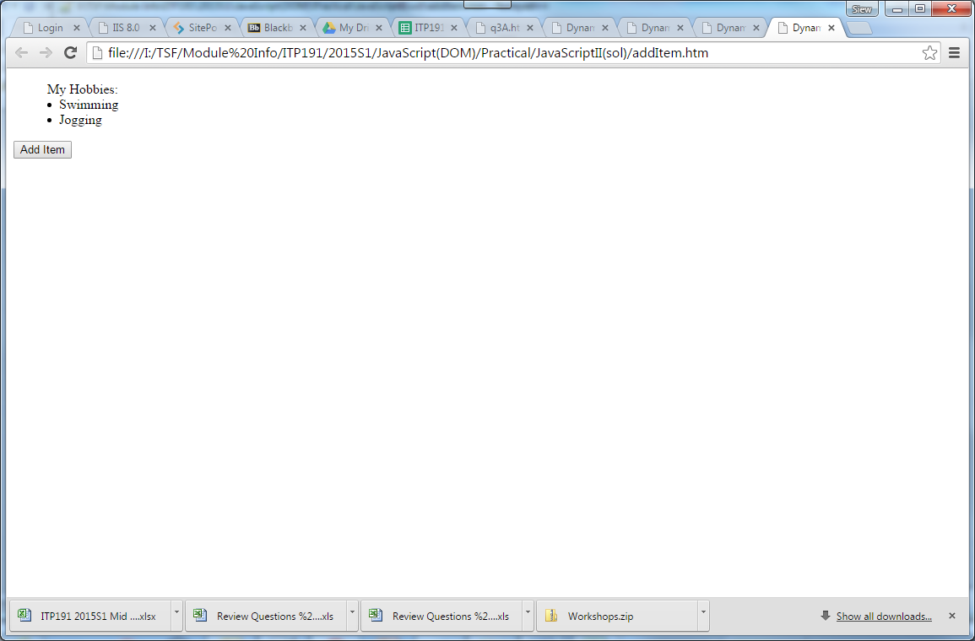 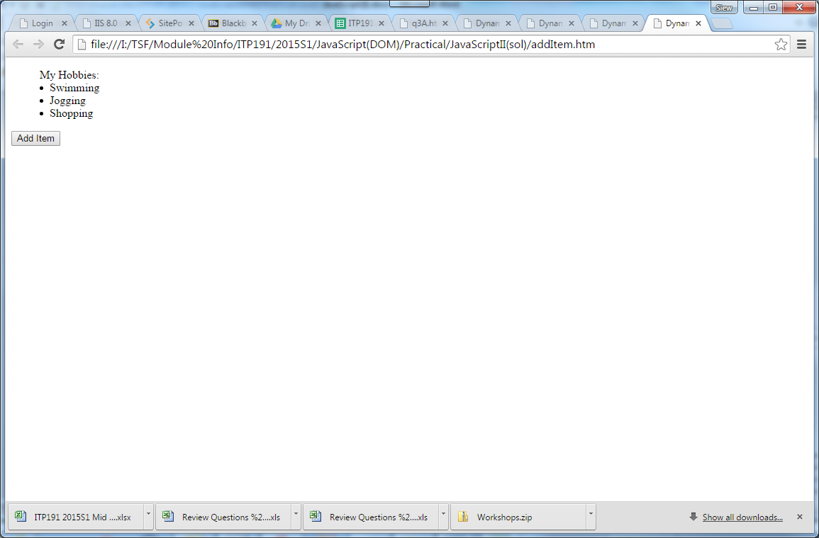  
 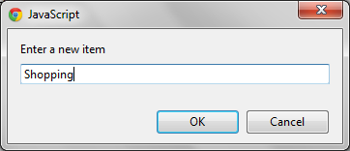  
   
   
**Steps:**

1. Copy the **addItem(Incomplete).html** to your working folder.
2. Complete the function ***change()*** and save it as **addItem.html**.

## The above exercise let you experience how to add an html element to the web document dynamically.

## Draw a DOM tree of before and after one item is added as above.

After adding “Shopping”

Before adding “Shopping”

## Challenge

Write a simple game using JavaScript time events. (Usage of setTimeout, setInterval, clearTimeout, clearInterval)

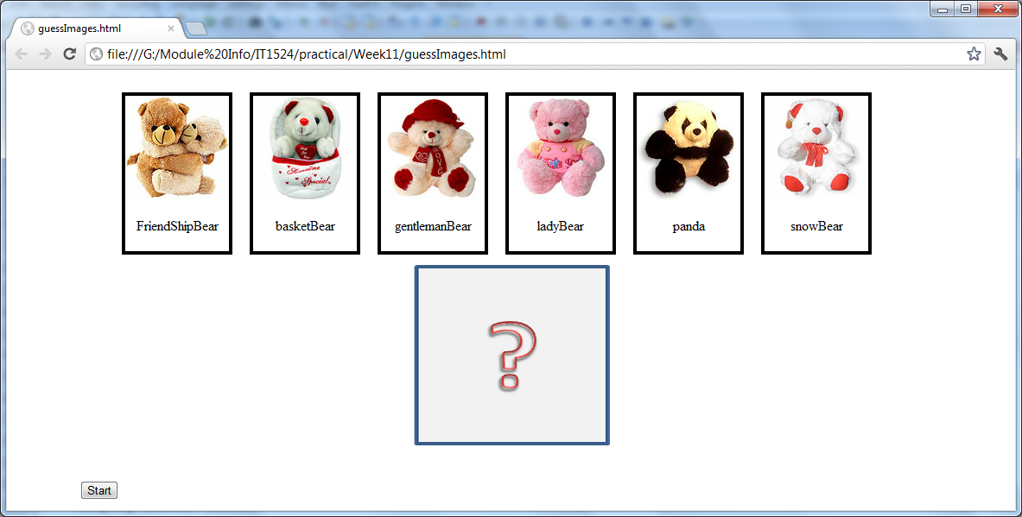

When the start button is clicked:

1. Pictures of bears will be flashed randomly for 2 seconds.
2. User will then be asked how many times a particular(randomly picked) picture appeared

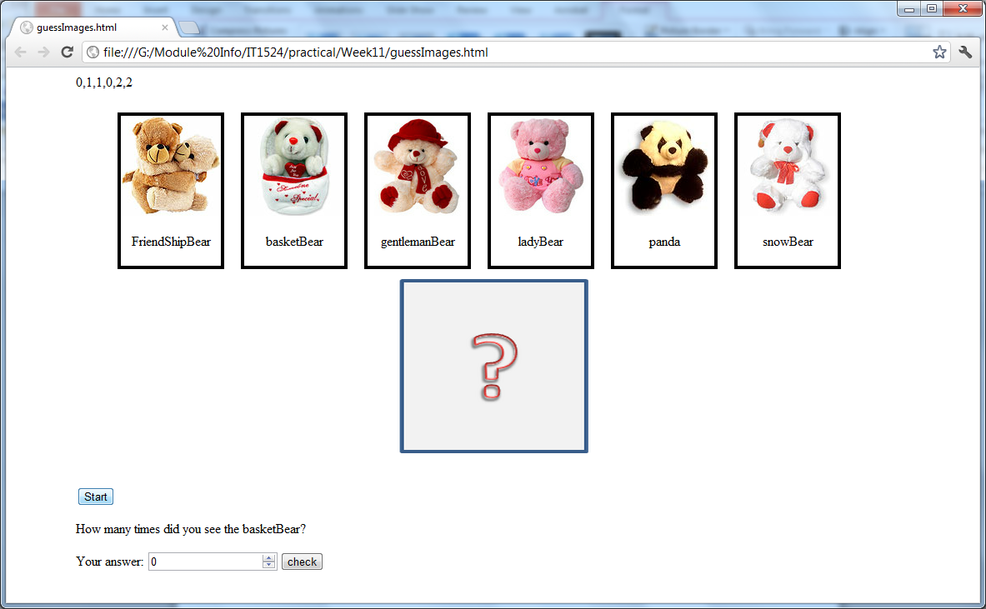

1. User enters answer and click at the check button to check answer.
2. Program checks answer and prompt accordingly.

*Incomplete codes can be found at* ***guessImages(Incomplete).html****.*